Trend-and-Season Regression for Monthly Solar Irradiance Forecasting
[Member 4 name]
[University and faculty]
BMMS2094 Statistics for Data Science · Student ID: [ID] · Tutorial/Group: [Identifier]
Assigned model: Multiple linear regression (trend + season) · Submission date: [DD Month YYYY]

Abstract—This report evaluates a multiple linear regression with deterministic trend and monthly seasonal indicators for NASA POWER surface solar irradiance in Kuala Lumpur. The model achieved test RMSE 0.2988 but failed the lag-24 residual white-noise diagnostic, limiting its suitability as a standalone forecaster.
Keywords—forecasting, linear regression, monthly seasonality, solar irradiance, time trend.

Methodology
This report proposes evaluating multiple linear regression for monthly NASA POWER solar irradiance in Kuala Lumpur [1]. The proposed model is
$$y_{t}=β_{0}+β_{1}t+\sum_{j=2}^{12}{δ_{j}}D_{j,t}+ε_{t},$$
where $t$ is the numerical month index, January is the reference month, and eleven indicators represent February–December. forecast::tslm() creates the trend and season variables from the time-series attributes [2]. Simple trend-only regression was excluded because it cannot represent recurring calendar-month effects; the trend term would estimate movement after controlling for month.
The common chronological split would use January 2001–December 2020 for fitting and January 2021–December 2025 for final testing. Both are full annual cycles; random splitting would leak future information. The need for transformation would be assessed from training data only, with response-scale modelling preferred when variance diagnostics did not justify transformation.
The locked formula would be tslm(train ~ trend + season). The training time plot and STL decomposition would be used to describe the direction and strength of trend and annual seasonality before interpreting the fitted terms; they would not be used to remove the assignment-required trend term. Ordinary least squares assumes a linear conditional mean, constant error variance, and uncorrelated errors. Coefficients and their uncertainty, adjusted $R^{2}$, residual standard error, and expanding-window validation at a 12-month horizon would be used to assess explanatory and forecasting performance [3].
Response residuals would be inspected over time and by ACF, followed by a lag-24 Ljung–Box test with fitted regression degrees of freedom [4]. Material autocorrelation would trigger consideration of regression with ARIMA errors, while the locked assignment model would remain available for the common comparison.

Results, Discussion, and Conclusion
Training evidence and model identification—The 2001–2020 time plot and STL decomposition showed a clear recurring annual pattern but only modest long-term movement. This supported explicit monthly indicators and cautioned against claiming a strong trend. The assignment-required trend + season formula was nevertheless retained so that the trend could be estimated after controlling for month rather than discarded by visual inspection alone.
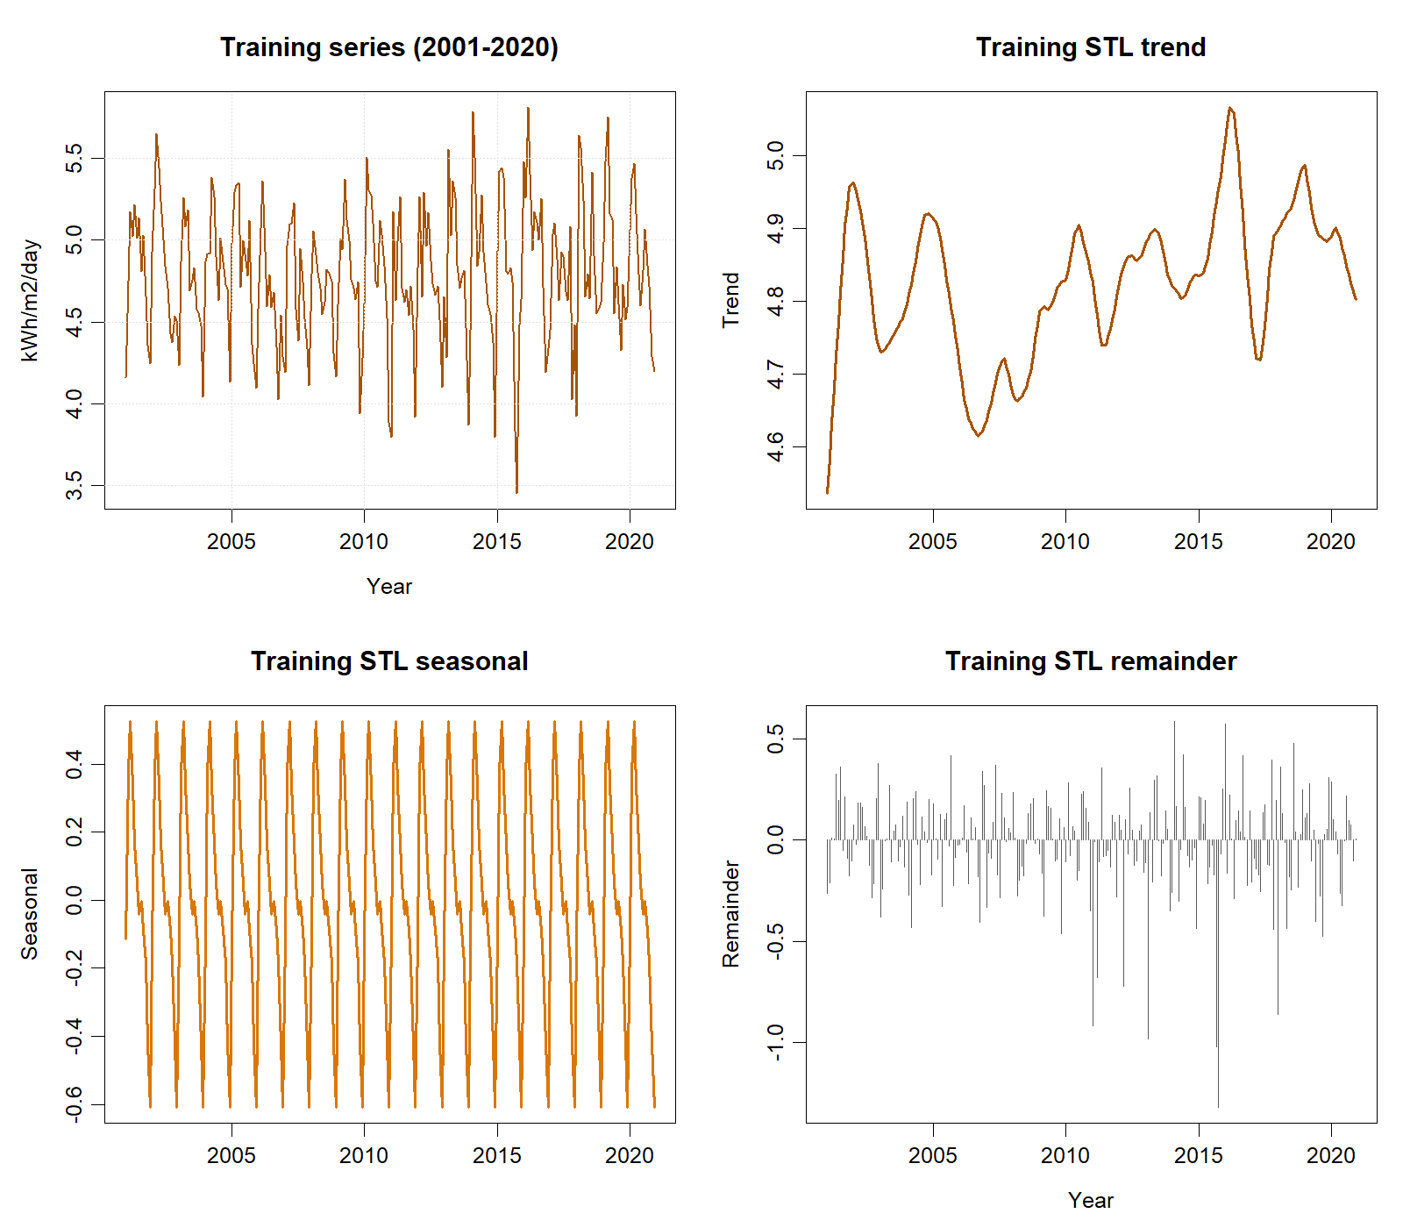
Training-only time series and STL components used for model identification.

The fitted model had adjusted $R^{2}=.5358$ ($R^{2}=.5591$; residual SE=.2817). Relative to January, the estimated March effect was +0.6468 and the December effect was −0.4147 kWh/m²/day. The trend estimate was +0.000381 per month (SE=0.000263, $p=.148$), so a strong trend was unsupported. Expanding-window validation at $h=12$ used 217 origins and yielded RMSE=.3545 and MAE=.2681. At lag 24 with 13 fitted coefficients, Ljung–Box gave $Q=32.622$, $p<.001$, rejecting residual white noise.
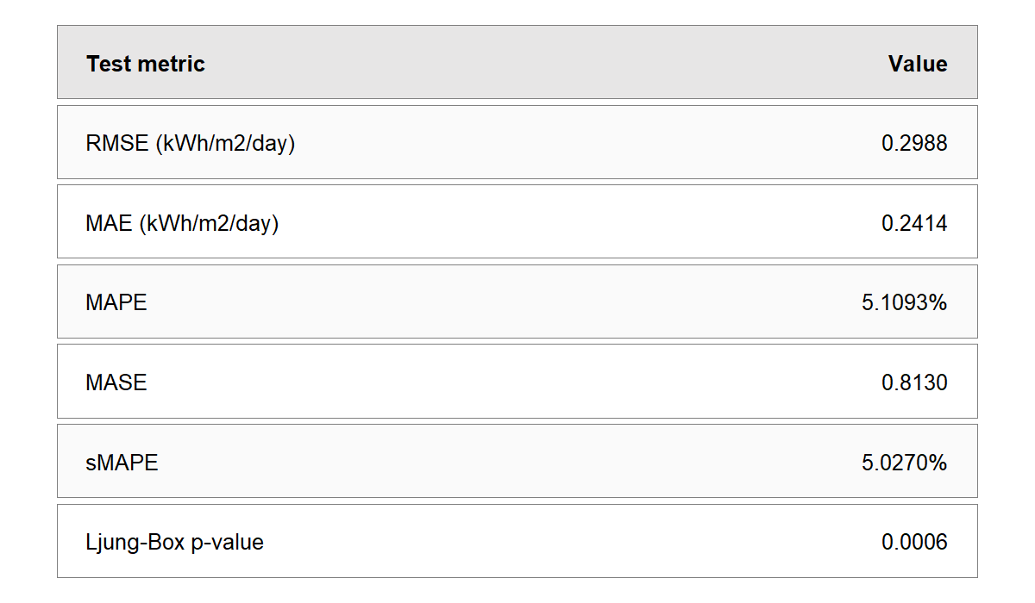
Trend-plus-season regression test accuracy and residual diagnostic.
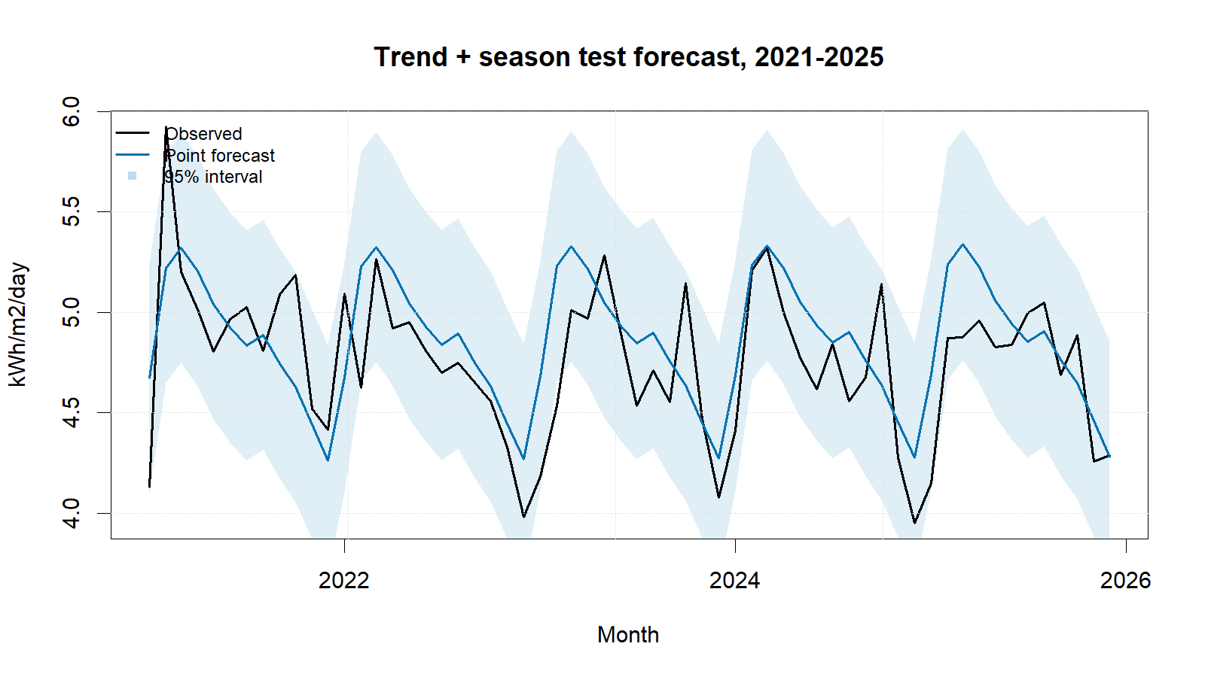
Trend-plus-season regression test forecasts with 95% intervals.
Regression ranked third by RMSE and produced non-negative point forecasts. Its strength is direct interpretation: recurring month effects explain substantial variation, while the small uncertain trend prevents an exaggerated long-run claim. Its main weakness is decisive residual autocorrelation; fixed month effects and a linear trend do not capture remaining temporal dependence. Fixed linear extrapolation and homoscedastic independent-error assumptions are additional limitations.
The specified regression is useful descriptively but is not adequate as the final standalone forecasting model. The strongest extension is regression with ARIMA errors, preserving interpretable trend/month effects while modelling serial correlation. Fourier seasonality, structural-change terms, robust variance checks, and rolling-origin comparisons are also recommended. Any irradiance forecast remains a solar-resource estimate, not photovoltaic electricity output.

References
[1] NASA Prediction Of Worldwide Energy Resources, ‘Monthly and annual API’. Accessed: Sep. 01, 2026. [Online]. Available: https://power.larc.nasa.gov/docs/services/api/temporal/monthly/
[2] M. O’Hara-Wild and R. J. Hyndman, ‘Fit a linear model with time series components’. Accessed: Sep. 01, 2026. [Online]. Available: https://pkg.robjhyndman.com/forecast/reference/tslm.html
[3] R. J. Hyndman and G. Athanasopoulos, Forecasting: Principles and practice, 3rd edn. Melbourne, Australia: OTexts, 2021. Available: https://otexts.com/fpp3/
[4] R. J. Hyndman, ‘Check that residuals from a time series model look like white noise’. Accessed: Sep. 01, 2026. [Online]. Available: https://pkg.robjhyndman.com/forecast/reference/checkresiduals.html

Appendix A: Reproducible Regression Code
Canonical source: ../NASA_Solar_Irradiance_Forecasting.R. No random procedure is used.
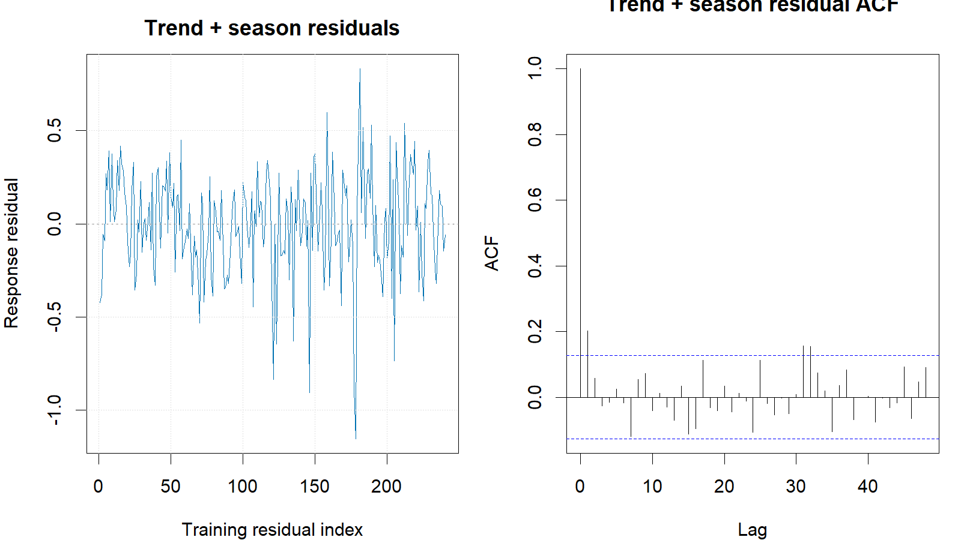
Regression training response residuals and residual ACF.
train <- window(series, end = c(2020, 12))
test <- window(series, start = c(2021, 1))
trend_season <- tslm(train ~ trend + season)
reg_fc <- forecast(trend_season, h = length(test), level = c(80, 95))
reg_res <- as.numeric(train) - as.numeric(fitted(trend_season))
Box.test(reg_res, lag = 24, type = "Ljung-Box",
fitdf = length(coef(trend_season)))
cv_fun <- function(y, h) forecast(tslm(y ~ trend + season), h = h)
cv_h12 <- tsCV(train, cv_fun, h = 12)[, 12]
metric_row("Trend + season", reg_fc, test, train)

